BIOL 116 Quiz B
Respond in full sentences, and explain all your responses.
1. This stained micrograph shows onion root tip cells. Identify a cell in each of these phases: interphase, metaphase, anaphase. Explain the basis of your identification.
(Note: Cells appear differently in different focal planes. Pick ones that look clear to you.)
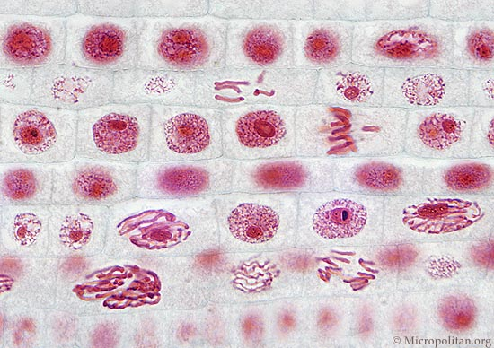

2. For the experiment of Fox et al (shown in Wednesday powerpoint), suppose you have a fluorescent antibody marker for a protein that occurs only during meiotic prophase I.
Explain what pattern of label you would see in Figure B, and why.
Sketch the pattern of percent labeled cells you would find in Figure C.

